**Analysis and Findings**

**The accompanying bar shows the precentage of the reservations that are canceled and those that are not**

**There are 62% of clients that are not canceled their reservations**

**And 37% of clients that are canceled their reservation which has a significant impact on the hotel’s earnings.**

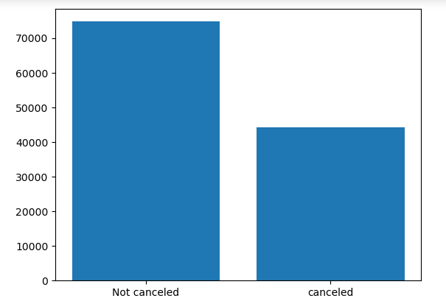

**In this comparison**

**Breakfast type meal most reservations are not canceled but there is also too much reservation that are cancelled.**

**It’s possible that clients want more variety type meal to be offered.**

**In comparison to resort hotels, city hotels have more bookings. It’s possible that resort hotels are more expensive than city hotels.**

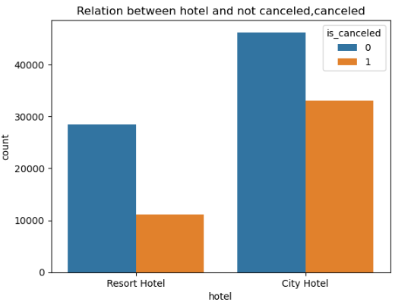

**The line graph above shows that, on certain days the average daily rate for a city hotel is less than of a resort hotel and on other days it is even less.**

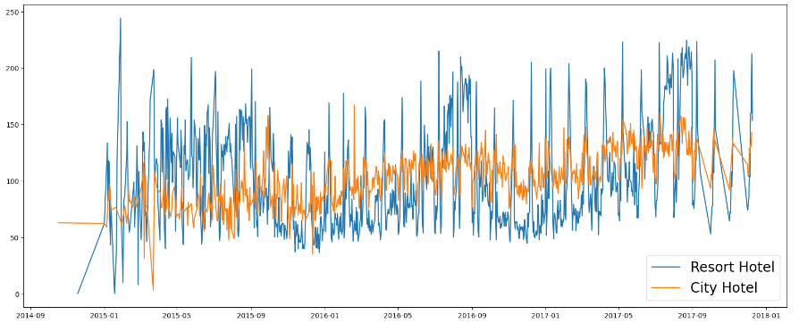

**This bar graph shows the months with the highest and lowest reservations.**

**As can be seen, both the number of confirmed reservations is largest in august, While the number of not confirmed reservations is largest in January.**

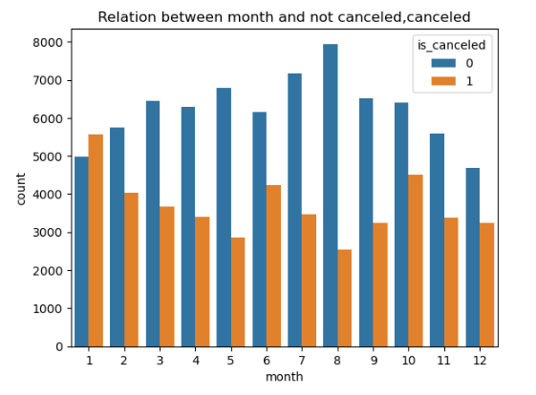

**This bar graph shows that cancellations reservations are most when prices are greatest and are least common they are lowest**

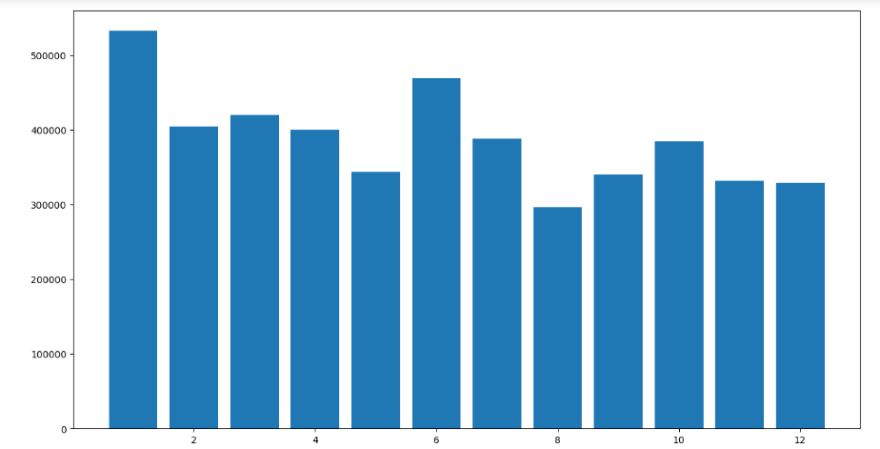

**Now, let’s see which country has the highest reservation canceled.**

**The top country is portugal**

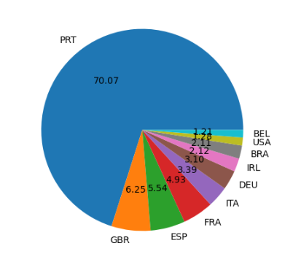

**Suggestions**

1. **Cancellation rate rise as the price does. In order to prevent cancellation of reservations. Hotels could work on their pricing strategies and try to lower the rates for specific hotels based on location. They can also provide some discounts to the consumers.**
2. **Clients want more variety type meal to be offered, hotels need to add more types of meal.**
3. **As the ratio of the cancellation and not cancellation of the city hotels is higher than resort hotels, the hotels should provide a reasonable discount on the room prices.**
4. **As most of online reservation is canceled, they can increase the quality of their hotels mainly in Portugal to reduce cancellation rate.**